# MIS 275 - Lab 6

Once you have completed the assignment then upload it to Blackboard. Save your document with the following naming convention:

* Course_Lab Number_First Initial Last Name (Example: MIS275_Lab6_LStewart.docx)

Complete Chapter 5 Case 10 (Cengage Pg. 194)

For Case 10 paste a screen print of your ERD here.

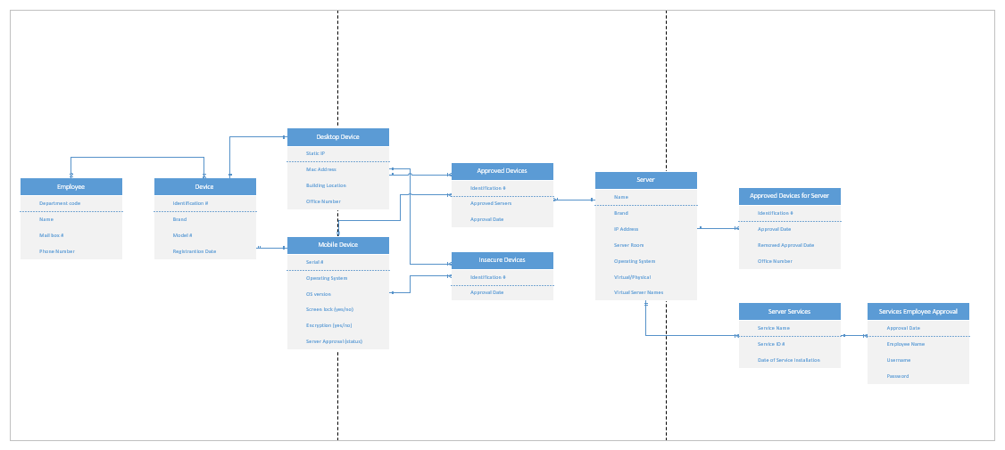

Complete Chapter 6 Problem 1 (Cengage Pg. 237)

For Case 10 paste screen prints of your dependency diagrams here. You should have multiple diagrams showing your work as you progress toward 3NF. Your final diagram should be in 3NF.

